A Task Analysis (TA) is used to assess the risks to health and safety for a specific task. You can identify hazards and risks and then choose controls (eliminate or minimise) to manage those risks. For more information refer to your HazardCo Resources.

General information:
PCBU name: |  | Completed by:
Contact number: |  | Site address:

Reference documents: This TA has been written using the latest NZ Legislation and industry guidelines

Best Practice Guidelines for working on roofs. Published by WorkSafe June 2012
Best Practice Guidelines - Working at Heights. Published by WorkSafe April 2012
Best Practice Guidelines – Mobile Elevating Work Platforms. Published by WorkSafe August 2014
Best Practice Guidelines - Safe use of safety nets. Published by WorkSafe May 2014

Prior to commencing any work on the worksite please ensure you have read and understood the Safety Procedures Section of your HazardCo resources. Ensure that the worksite is set up as per the Work Preparation Page.

Please contact HazardCo on 0800 555 339 if you require any assistance to identify hazards or implement the required controls
WorkSafe NZ decision tree for preventing falls from a roof
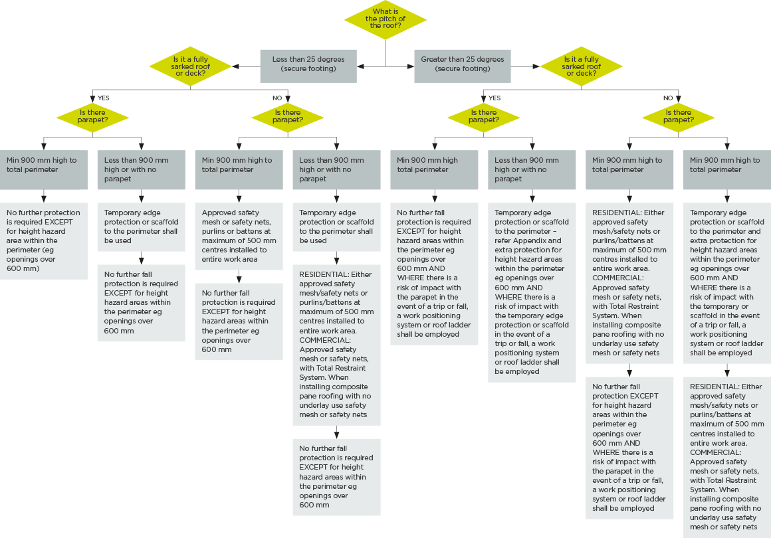

Hazard ID and risk management

The following questions are task specific and will help identify if a particular hazard or risk is likely to be present during the task.
If you have answered yes to any of the questions below you must where possible eliminate (E) the risk, if you cannot do so then you must put in place multiple controls to minimise (M) the risk.
Below is a list of risk controls that are based on regulations, industry expectations and good practice guidelines (referenced on the front of this TA). The controls are listed from most effective to the least effective. Remember to monitor the effectiveness of your controls through on-going Site Reviews.

Answer the following questions relevant to the task you are about to complete |  |  | Hazard/risk identified | Specify the risk controls you will use
- Are you removing asbestos cement roofing or ceiling tiles? |  | ☐ Yes ☐ No | Friable ACM /High Risk of Asbestosis and lung disease (Do not proceed if you are unlicensed) | ☐ Only licensed (Class A) removalist to remove Friable Asbestos.  Cement roofing must be considered friable as very few roofs are in good condition. Ceiling tiles are easily broken and must be considered friable.  (Refer to Asbestos Task Analysis).
- Will there be a risk of fall from height? |  | ☐ Yes ☐ No | Fall from heights resulting in injury, incident of death | ☐ Work to be done at ground level (E);  ☐ Appropriate guarded work platform to be provided e.g. scaffold, EWP edge protection or similar (M);  ☐ Fall restraint system to be used (M);  ☐ Soft landing systems to be used e.g. safety nets, air and bean bags (M);  ☐ Ladders to be used as a last resort and for short periods only (M).
- Will there be any work carried out on ladders? |  | ☐ Yes ☐ No | Fall from heights resulting in injury, incident or death | ☐ Don’t use ladders as a working platform, replace with podium ladders or a guarded work platform (E);  ☐ Ladders to be used as a last resort and for short duration only (M);  ☐ Use only commercial grade ladders rated to at least 120kg that comply with AS/NZS (M);  ☐ Do not use 3 step ladders (M);  ☐ Only use ladders for access to the work area or a working platform (M);  ☐ Conduct a visual inspection before each use and regular maintenance checks (M);  ☐ Use Ladder Stability Devices (LSD) to prevent slipping or lateral movement (M);  ☐ Set up straight ladders correctly e.g. 4 up 1 out method with 1 metre overlap on a roof edge, ensure all stabilising stays/locking clips/locking arms are engaged securely (M);  ☐ Maintain 3 points of contact at all times (M);  ☐ Always stop at the 3rd step from the top of a straight ladder (M);  ☐ Carry tools on a tool belt and don’t over reach (M);  ☐ Place suitable barriers around ladder where necessary e.g. when working in drive ways or corridors (M).
Answer the following questions relevant to the task you are about to complete |  |  | Hazard/risk identified | Specify the risk controls you will use
- Will there be any work carried out on scaffolding or edge protection? | ☐ Yes ☐ No |  | Scaffold collapse/ fall from height resulting in injury, incident or death | ☐ Scaffolding/edge protection to be set up by trained and competent persons (M);  ☐ Any scaffolding 5m and over must to be installed by certified person only and WorkSafe notified (M);  Refer to Scaffold or Working at Height Task Analysis when using scaffold.
- Will there be any work carried out on an EWP? | ☐ Yes ☐ No |  | EWP tip over / fall from height resulting in injury, incident or death | ☐ Competent/Trained staff only to operate EWP (As per EWP good practice guidelines) (M);  ☐ Daily maintenance checks to be done (see relevant checklist) (M);  ☐ Safety observer to be used (M);  ☐ Exclusion zone set up (M);  ☐ High Risk Response Plan in place (M).  Refer to the Working at Height Task Analysis when using an EWP.
- Will you be using harness and lanyard systems | ☐ Yes ☐ No |  | Fall from heights / suspension trauma resulting in injury or death | ☐ Competent/Trained staff only to use harnesses (As per working at heights best practice guidelines) (M);  ☐ Daily safety checks to be done (M);  ☐ Rescue plan in place (M);  Refer to the Working at Height Task Analysis when using a harness system
- Will you be using safety nets? | ☐ Yes ☐ No |  | Fall from heights resulting in injury or death | ☐ Safety nets to be set up by trained and competent persons (M);  ☐ Handover document, instructions on use and rescue plan handed over from installer (M);  ☐ Safety nets have a current test and tag label attached (M);  ☐ Workers are trained and competent in using safety nets and carrying out a rescue (M);  ☐ Visual inspections will be carried out daily (by user), weekly and after adverse weather (by site supervisor) (M);
- Will work be affected by high winds, rain, ice, frost or snow? | ☐ Yes ☐ No |  | High winds or slips causing falling objects or fall from height resulting in injury, incident or death | ☐ Postpone working at heights (E);  ☐ Secure tools, materials and equipment (M);  ☐ Use appropriate fall protection and PPE (M);  ☐ Use the correct footwear for the job (M).
- Will materials be lifted by crane/forklift or similar? | ☐ Yes ☐ No |  | Insecure overhead loads causing falling objects resulting in injury, incident or death | ☐ Competent/trained staff only to operate crane/forklift (M);  ☐ Lift plan in place and sighted by all those involved (M);  ☐ Exclusion zone set up (M);  ☐ Safety observer to be used (M);  ☐ All non-essential workers and visitors kept clear while lifting occurs (M).

Answer the following questions relevant to the task you are about to complete |  | Hazard/risk identified | Specify the risk controls you will use
- Will the work being undertaken involve repetitive lifting, bending, twisting or other types of manual handling? | ☐ Yes ☐ No | Strain or sprain from manual handling resulting in injury | ☐ A mechanical aid is required as the materials being lifted are too heavy or awkward to lift manually i.e. EWP, forklift etc (E);  ☐ All workers require training in correct manual handling techniques (bend knees, keep back straight, lift with your legs & keep load close in front of you) (M);  ☐ Store materials to reduce manual handling risks e.g. between knee & shoulder height (M);  ☐ Ensure a two person lift for large, awkward or heavy objects (M);  ☐ Rotate work load (M).
- Will there be a risk of electrical exposure? | ☐ Yes ☐ No | Coming in contact with live voltage lines resulting in injury, incident or death | ☐ Ensure all electrical outlets including the position of wiring to lights should be noted on the task analysis, and where applicable on the building plans (M);  ☐ Consult with electrical specialist to ensure all electrical cabling is isolated prior to commencing work (M).
- Will any work at height encroach within 4 metres of high voltage power lines? | ☐ Yes ☐ No | Coming in contact with live high voltage lines resulting in injury, incident or death | ☐ Do not work within 4m of power lines (E);  ☐ Obtain permission from local authority before commencing work (M);  ☐ Power to be isolated at the source by a qualified electrician (M);  ☐ Safe approach distance to be marked using visual identification e.g. tiger tails (M);  ☐ Spotter to be used when moving vehicles/machinery on site (M);  ☐ All equipment to have a mobile earth attached when being used within 4m (M).  ☐ Emergency response procedures will be in place (M).
- Will there be hand, power, or pressure tools used? | ☐ Yes ☐ No | High noise levels can cause Noise Induced Hearing Loss (NIHL) | ☐ Purchase equipment with low noise emissions (E);  ☐ Isolate noisy equipment away from non-essential workers and visitors (M);  ☐ Implement job rotation to reduce duration of exposure (M);  ☐ Maintain and service equipment which takes into account noise (M);  ☐ Use the correct personal protective equipment for the job (M);  ☐ Carry out yearly hearing tests as part of a Health Monitoring Plan (M);  ☐ Ensure appropriate warning signage is in place (M).

Additional task information

Add any additional hazards or risks that you identify for this task that are not listed above.

PPE required: |  | Signage required:

Work method statement

Describe how you plan to carry out the task by listing the step by step process eg 1. Arrive on site, 2. unload truck, 3. build scaffold etc. | Done
 | ☐
 | ☐
 | ☐
 | ☐
 | ☐
 | ☐
 | ☐
 | ☐
 | ☐
 | ☐
 | ☐
 | ☐
 | ☐
Safety briefing

You must conduct a safety briefing with all workers involved in this task. Explain the identified hazards and associated risks, the controls that will be put in place, and the proposed work method.

Name: |  | Signature:

Completed by: |  | Signed: |  | Date:

