A Task Analysis (TA) is used to assess the risks to health and safety for a specific task. You can identify hazards and risks and then choose controls (eliminate or minimise) to manage those risks. For more information refer to your Safety Procedures Card.

General information:
PCBU name: |  | Completed by:
Contact number: |  | Site address:

Reference documents: This TA has been written using the latest NZ Legislation and industry guidelines

Confined Spaces code of Practice
Health and Safety at Work Regulations 2016

Prior to commencing any work on site please ensure you have read and understood your Safety Procedure Cards. Ensure that the work site is set up as per the Work Preparation Card.
Please contact HazardCo on 0800 555 339 if you require any assistance to identify hazards or implement the required controls

To determine if your works are restricted space works or confined space works use this flow chart from the Confined Spaces code of Practice:
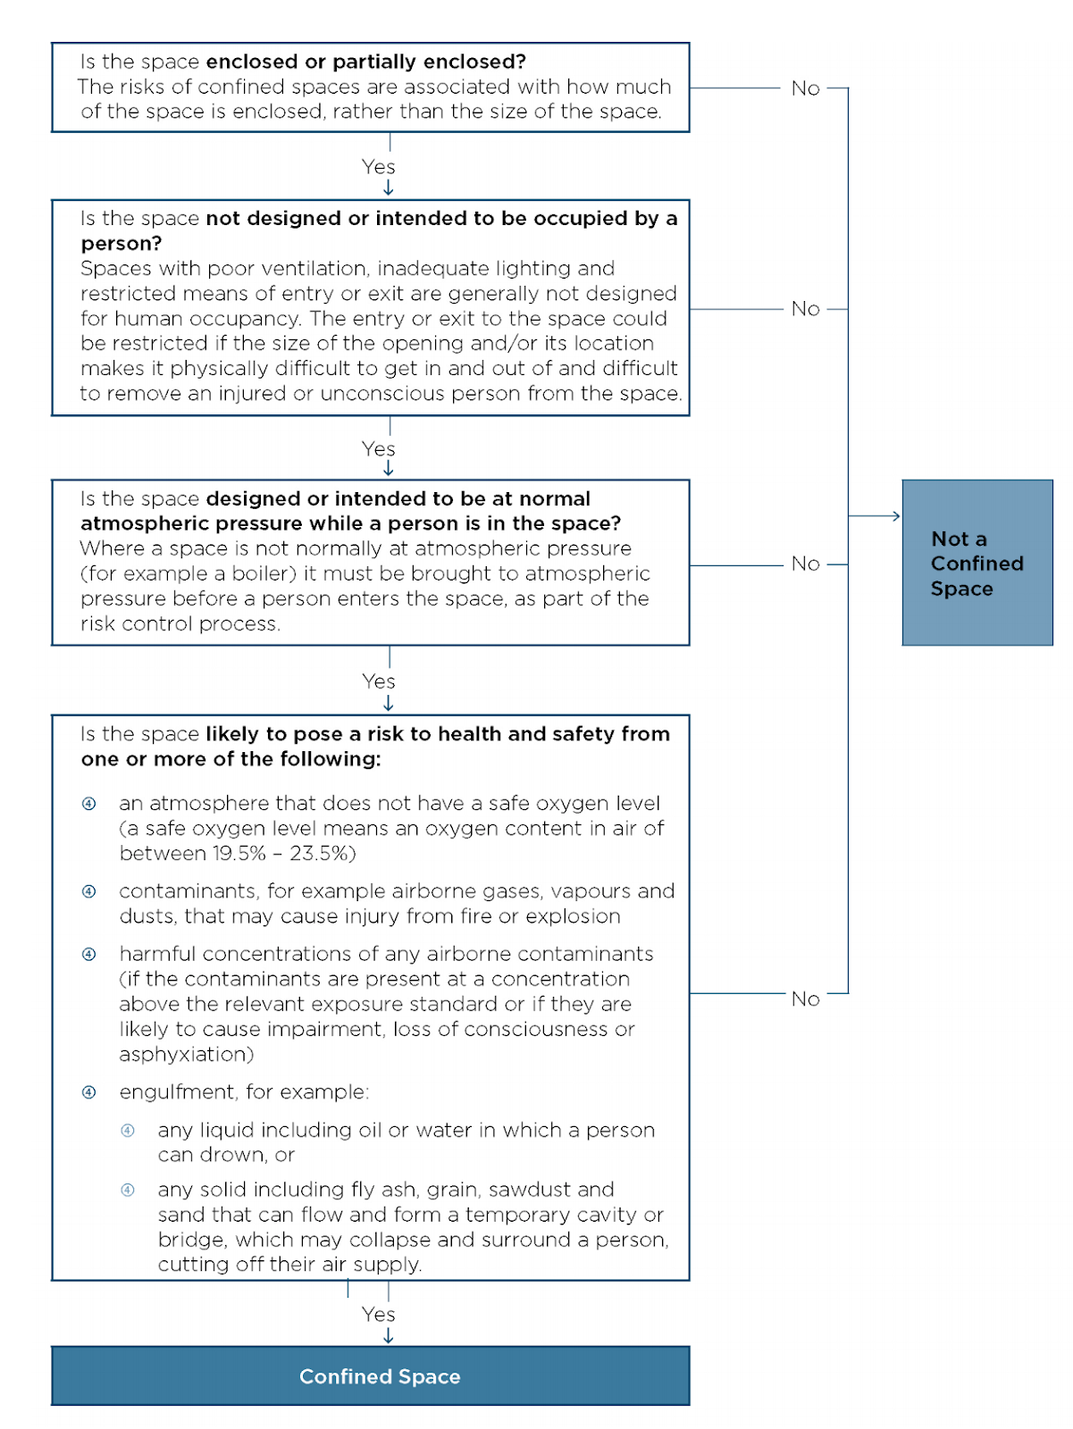

Hazard ID and Risk Management

The following questions are task specific and will help identify if a particular hazard or risk is likely to be present during the task.
If you have answered yes to any of the questions below you must where possible eliminate (E) the risk, if you cannot do so then you must put in place multiple controls to minimise (M) the risk.
Below is a list of risk controls that are based on regulations, industry expectations and good practice guidelines (referenced on the front of this TA). The controls are listed from most effective to the least effective. Remember to monitor the effectiveness of your controls through on-going Site Reviews.

Answer the following questions relevant to the task you are about to complete |  | Hazard/risk identified | Specify the risk controls you will use
- Will there be any work conducted in the roof space or under the floor? | ☐ Yes ☐ No | Restricted space entry resulting in entrapment causing, injury, incident or death. | ☐ Do not enter areas that are not large enough to comfortably exit (M);  ☐ Use standby person (M);  ☐ Make sure you have a rescue plan in place in the event of an emergency (M);  ☐ Ensure appropriate ventilation and lighting (M);  ☐ Ensure you have had some basic confined space training (M);  ☐ Monitor temperature (M);  ☐ Take Regular breaks (M);  ☐ Use the appropriate PPE eg Knee pads, dust masks (M);
- Are there exposed (hanging) or damaged electrical cables, or could you come in contact with live electrical cables whilst undertaking the work? | ☐ Yes ☐ No | Contact with electrical services resulting in injury, incident or death | ☐ Ensure all electrical outlets including the position of wiring to lights should be noted on the task analysis, and where applicable on the building plans (M);  ☐ Consult with electrical specialist to ensure all electrical cabling is isolated prior to commencing work (M).
- Will the work be conducted in a hazardous environment e.g. dust, fumes, vapours or gases? | ☐ Yes ☐ No | Exposure to hazardous environments/airborne substances resulting in injury, illness, incident or death. | ☐ Non-essential workers must be isolated from work areas (M);  ☐ Good ventilation/extraction/vacuum systems are required for the work being carried out (M);  ☐ Yearly lung function tests should be carried out as part of a Health Monitoring Plan, to ensure no workers are suffering any ill effects from the work they are carrying out (M);  ☐ Ensure appropriate warning signage is in place (M);  ☐ All PPE must be fitted correctly e.g. facial hair will prevent correct seal with face (M);  ☐ The correct PPE e.g. respirators/fitted dust masks must be used to prevent contaminants from being inhaled (M).
Answer the following questions relevant to the task you are about to complete |  | Hazard/risk identified | Specify the risk controls you will use
- Will any hazardous substances be used? | ☐ Yes ☐ No | Exposure to hazardous substances resulting in injury, illness or death. | ☐ Remove all hazardous substances from the workplace (E);  ☐ Replace hazardous substances with non-hazardous substances (E);  ☐ Handle/store/dispose of hazardous substances as per the Safety Data Sheet (SDS) and Regulations (M);  ☐ Record all hazardous substances on a register (M);  ☐ Only trained and/or supervised workers to handle hazardous substances (M);  ☐ Use the correct PPE as per the SDS when handling or working with hazardous substances (M);  ☐ Ensure appropriate warning signage is in place (M);  ☐ Required PPE to be used (M).
- Will you be working in poor lighting? | ☐ Yes ☐ No | Workers exposed to being struck or hitting obstructions resulting in injury, incident or death | ☐ Artificial lighting available where there is insufficient natural light (M);  ☐ Clear communication procedures will be in place (M)  ☐ There will be no lone workers (M);
- Are electrical appliances going to be used? | ☐ Yes ☐ No | Unsafe tools and practices resulting in injury, incident or death | ☐ Use tagged and tested RCD’s, leads and electrical appliances (M);  ☐ Check leads in good condition (M).
- Will there be hand, power, or pressure tools used? | ☐ Yes ☐ No | Unsafe tools and practices resulting in injury, incident or death | ☐ Unsafe tools need to be removed from service (E);  ☐ Use tagged and tested RCD’s, leads and electrical appliances (M);  ☐ Workers are trained and competent prior to use(M);  ☐ All guards will be in place (M);  ☐ All equipment to be inspected prior to use and documented (M);  ☐ The appropriate PPE needs to be used by all workers eg hearing/eye protection, footwear etc. (M).
- Will noise levels be above 85dB? | ☐ Yes ☐ No | High noise levels resulting in Noise Induced Hearing Loss (NIHL) | ☐ Purchase equipment with low noise emissions (E);  ☐ Isolate noisy machinery and equipment away from non-essential workers and visitors (M);  ☐ Implement job rotation to reduce duration of exposure (M);  ☐ Maintain and service machinery (take into account noise) (M);  ☐ Carry out yearly hearing tests as part of a Health Monitoring Plan (M);  ☐ Ensure appropriate warning signage is in place (M);  ☐ Use the correct hearing protection for the job (M).
Answer the following questions relevant to the task you are about to complete |  | Hazard/risk identified | Specify the risk controls you will use
- Will there be a risk of fall from height? | ☐ Yes ☐ No | Fall from heights resulting in injury, incident of death | ☐ Work to be done at ground level (E);  ☐ Appropriate guarded work platform to be provided e.g. scaffold, EWP edge protection or similar (M);  ☐ Fall restraint system to be used (M);  ☐ Soft landing systems to be used e.g. safety nets, air and bean bags (M);  ☐ Do not stand on ceiling panels (M);  ☐ Complete working at height TA (M);  ☐ Use appropriate fall protection and PPE (M).
- Will there be any work carried out on ladders? | ☐ Yes ☐ No | Fall from heights resulting in injury, incident or death | ☐ Don’t use ladders as a working platform, replace with podium ladders or a guarded work platform (E);  ☐ Ladders to be used as a last resort and for short duration only (M);  ☐ Use only commercial grade ladders rated to at least 120kg that comply with AS/NZS (M);  ☐ Do not use 3 step ladders (M);  ☐ Only use ladders for access to the work area or a working platform (M);  ☐ Conduct a visual inspection before each use and regular maintenance checks (M);  ☐ Use Ladder Stability Devices (LSD) to prevent slipping or lateral movement (M);  ☐ Set up straight ladders correctly e.g. 4 up 1 out method with 1 metre overlap on a roof edge, ensure all stabilising stays/locking clips/locking arms are engaged securely (M);  ☐ Maintain 3 points of contact at all times (M);  ☐ Always stop at the 3rd step from the top of a straight ladder (M);  ☐ Carry tools on a tool belt and don’t overreach (M);  ☐ Place suitable barriers around ladder where necessary e.g. when working in driveways or corridors (M).
Answer the following questions relevant to the task you are about to complete |  | Hazard/risk identified | Specify the risk controls you will use
- Will the work being undertaken involve repetitive lifting, bending, twisting or other types of manual handling? | ☐ Yes ☐ No | Manual Handling | ☐ A mechanical aid is required as the materials being lifted are too heavy or awkward to lift manually (E);  ☐ All workers are trained in the correct manual handling techniques (bend knees, keep back straight, lift with your legs, keep load close in front of you) (M);  ☐ Store materials to reduce manual handling risks e.g. between knee and shoulder height (M);  ☐ Ensure a two person lift for large, awkward or heavy objects (M);  ☐ Rotate workload with other workers (M).
 | ☐ Yes ☐ No |  | ☐  ☐  ☐  ☐
 | ☐ Yes ☐ No |  | ☐  ☐  ☐  ☐
 | ☐ Yes ☐ No |  | ☐  ☐  ☐  ☐
 | ☐ Yes ☐ No |  | ☐  ☐  ☐

Additional task information
Add any additional hazards or risks that you identify for this task that are not listed above.

PPE required: |  | Signage required:

Work method statement

Describe how you plan to carry out the task by listing the step by step process eg 1. Arrive on site, 2. unload truck, 3. build scaffold etc. | Done
 | ☐
 | ☐
 | ☐
 | ☐
 | ☐
 | ☐
 | ☐
 | ☐
 | ☐
 | ☐
 | ☐
 | ☐
 | ☐
Safety briefing

You must conduct a safety briefing with all workers involved in this task. Explain the identified hazards and associated risks, the controls that will be put in place, and the proposed work method.

Name: |  | Signature:

Completed by: |  | Signed: |  | Date:

