d
A Task Analysis (TA) is used to assess the risks to health and safety for a specific task. You can identify hazards and risks and then choose controls (eliminate or minimise) to manage those risks. For more information refer to your Safety Procedures Card.

General information:
PCBU name: |  | Completed by:
Contact number: |  | Site address:

Reference documents: This T.A. has been written using the latest NZ Legislation and industry guidelines

Best Practice Guidelines – Working at Heights
Best Practice Guidelines – Mobile Elevated Work Platforms

Please contact HazardCo on 0800 555 339 if you require any assistance to identify hazards or implement the required controls
For the purpose of operating MEWP’s, a competent or licenced person is someone who has achieved and can demonstrate competency along with training to the NZQA unit standards below.
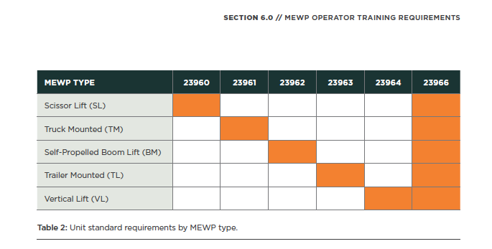
Table courtesy of ’Best Practice Guidelines – Mobile Elevated Work Platforms’

Prior to commencing any work on site please ensure you have read and understood your Safety Procedures Section of your HazardCo resources. Ensure that the worksite is set up as per the Work Preparation Page.

Hazard ID and risk management

The following questions are task specific and will help identify if a particular hazard or risk is likely to be present during the task.
If you have answered yes to any of the questions below you must where possible eliminate (E) the risk, if you cannot do so then you must put in place multiple controls to minimise (M) the risk.
Below is a list of risk controls that are based on regulations, industry expectations and good practice guidelines (referenced on the front of this TA). The controls are listed from most effective to the least effective. Remember to monitor the effectiveness of your controls through on-going Site Reviews.

Answer the following questions relevant to the task you are about to complete |  | Hazard/risk identified | Specify the risk controls you will use
- Will there be a risk of fall from height? | ☐ Yes ☐ No | Fall from height resulting in incident, injury or death | ☐ Work to be done at ground level (E);  ☐ Appropriate Mobile Elevated Work Platform (MEWP) to be identified and used correctly (M);  ☐ Fall restraint equipment to be checked, fitted and attached to certified anchor points (M);  ☐ All guardrails and toe boards are in place (M);  ☐ Emergency Rescue plan in place (M);  ☐ All training and competencies are held for operators of MEWP and equipment (M);  ☐ A safety spotter to be used (M).
- Will there be a risk of falling objects from above? | ☐ Yes ☐ No | Incident resulting in injury or death to people or damage to property | ☐ Exclusion zone set up and monitored closely (M);  ☐ Secure tools, materials and equipment and ensure toe boards are in place (M);  ☐ Tool belts and/or restraints to be used (M);  ☐ A safety spotter to be used (M);  ☐ Head protection (hard hats) to be worn by all people in the drop zone - PPE (M).
- Are the ground conditions assessed and stable? | ☐ Yes ☐ No | Overturn resulting in incident, injury or death | ☐ Ground conditions checked prior to MEWP use (M);  ☐ Underground services identified prior to use (M);  ☐ Use on firm level ground (M);  ☐ Temporary covers to block holes should be strong enough to withstand applied pressure and checked regularly or avoided as no-go zones (M);  ☐ Only use within the capabilities of the inclinometer (M).

Answer the following questions relevant to the task you are about to complete |  | Hazard/risk identified | Specify the risk controls you will use
- Will work be affected by high winds, rain, ice, frost or snow? | ☐ Yes ☐ No | Poor weather causing slips, trips and falls resulting in incident, injury or death | ☐ Refer to manufacturer’s specified wind rating limits and follow any required instructions (M);  ☐ Secure tools, materials and equipment (M);  ☐ Inspect platform before and after use (M);  ☐ Monitor weather conditions frequently and alter work plans as required (M);  ☐ Use appropriate fall protection and PPE (M).
- Are outriggers attached? | ☐ Yes ☐ No | Incorrect set up of outriggers could result in MEWP tipping resulting in incident, injury or death | ☐ Do not set up on slopes (E);  ☐ Set outriggers according to manufacturer's’ instructions (M);  ☐ Use spreader plates (M);  ☐ Ensure platform is level, after setting up outriggers (M).
- Will work be done near or over water? | ☐ Yes ☐ No | Fall from height into water resulting in incident, injury or death | ☐ A detailed rescue plan is in place (M);  ☐ A safety spotter to be used (M);  ☐ Use appropriate PPE – life jackets, harnesses, footwear and hard hats (M);
- Could you encroach on or come in contact with overhead power lines near your work (within 4m)? | ☐ Yes ☐ No | Workers coming in contact with high voltage lines resulting in incident, injury or death | ☐ Service owners will be contacted to de-energise power lines prior to commencing work (M);  ☐ Service owners will be contacted to isolate power lines using “tiger tails” or similar (M):  ☐ All mobile plant, machinery and equipment will be kept a minimum of 4m clear of any high voltage lines unless authorised/permitted by services owner (M);  ☐ Spotters will be used while moving equipment (M);  ☐ Equipment will be moved by competent operators (M);  ☐ Emergency response procedures will be in place (M).
Answer the following questions relevant to the task you are about to complete |  | Hazard/risk identified | Specify the risk controls you will use
- Will there be any confined overhead works? | ☐ Yes ☐ No | Crushing or entrapment resulting in injury, incident or death | ☐ Ensure briefing is conducted on the risks of working around the structures in the workplace (M);  ☐ Be aware of the working environment at all times  ☐ Wear hardhat with chin strap
- Are regular detailed checks completed and recorded? | ☐ Yes ☐ No | Failure of machine resulting in collapse/fall from height resulting in injury, incident or death | ☐ Daily checks and maintenance will be carried out as per manufacturer’s instructions (M);  ☐ Detailed service records are held in log book and/or on service stickers (M);  ☐ Inspections to be carried out by a qualified person and documented (M);
- Will any work be undertaken involving repetitive lifting, bending, twisting or other types of manual handling? | ☐ Yes ☐ No | Strain or sprain from manual handling resulting in injury | ☐ A mechanical aid is required if the materials being lifted are too heavy or awkward to lift manually; (E)  ☐ Check Safe Working Limit (SWL) of platform (M)  ☐ All workers require training in correct manual handling; (M)  ☐ Store materials to reduce manual handling risks; (M)  ☐ Ensure a 2 person lift for large, awkward, heavy objects; (M).
11. | ☐ Yes ☐ No |  | ☐  ☐  ☐
12. | ☐ Yes ☐ No |  | ☐  ☐  ☐

Additional task information
Add any additional hazards or risks that you identify for this task that are not listed above.

PPE required: |  | Signage required:

Work method statement

Describe how you plan to carry out the task by listing the step by step process eg 1. Arrive on site, 2. unload truck, 3. build scaffold etc. | Done
 | ☐
 | ☐
 | ☐
 | ☐
 | ☐
 | ☐
 | ☐
 | ☐
 | ☐
 | ☐
 | ☐
 | ☐

Safety briefing

You must conduct a safety briefing/talk with all workers involved in this task. Explain and discuss the identified hazards and associated risks, the controls that will be put in place, and the proposed work method.

Name: |  | Signature:

Completed by: |  | Signed: |  | Date:

