A Task Analysis (TA) is used to assess the risks to health and safety for a specific task. You can identify hazards and risks and then choose controls (eliminate or minimise) to manage those risks. For more information refer to your HazardCo Resources.

General information:
PCBU name: |  | Completed by:
Contact number: |  | Site address:

Reference documents: This TA has been written using the latest NZ Legislation and industry guidelines

Concrete Pumping Health and Safety Guidelines – February 2013

Health and Safety at Work (Hazardous Substances) Regulations 2017

Prior to commencing any work on the worksite please ensure you have read and understood the Safety Procedures Section of your HazardCo resources. Ensure that the worksite is set up as per the Work Preparation Page.

Please contact HazardCo on 0800 555 339 if you require any assistance to identify hazards or implement the required controls

Hazard ID and risk management

The following questions are task specific and will help identify if a particular hazard or risk is likely to be present during the task.
If you have answered yes to any of the questions below you must where possible eliminate (E) the risk, if you cannot do so then you must put in place multiple controls to minimise (M) the risk.

Below is a list of risk controls that are based on regulations, industry expectations and good practice guidelines (referenced on the front of this TA). The controls are listed from most effective to the least effective. Remember to monitor the effectiveness of your controls through on-going Site Reviews.

Ensure that a pre-start check is completed on the vehicle prior to use. As per the Concrete Pumping Health and Safety Guidelines ensure the area where concrete pump will be set up is:

☐ clear of excavations, trenches or holes in the ground
☐ clear of inadequately compacted or soft ground
☐ clear of cellars, basements, pits or back-filled ground, unless stability is approved in writing by a qualified engineer

☐ clear of overhead power lines and fixed electrical equipment
☐ of a size enough to allow for safe operation
☐ of a size enough to allow for the safe discharge from the concrete delivery trucks.

Answer the following questions relevant to the task you are about to complete |  | Hazard/risk identified | Specify the risk controls you will use
- Will the concrete vehicle be parked in a public area? | ☐ Yes ☐ No | Members of the public being exposed to hazards resulting in injury, incident or death | ☐ Area around the vehicle will be barricaded/fenced (M);  ☐ A spotter will be used to keep the public out of working area (M);  ☐ Signage erected to identify hazards present (M).
- Will workers come in contact with wet cement? | ☐ Yes ☐ No | Wet cement resulting in injury, illness or incident | ☐ Only trained and competent workers will handle wet cement (M);  ☐ Cement is listed on Hazardous Substance Register and the appropriate Safety Data Sheet (SDS) is available (M);  ☐ Appropriate protective clothing and equipment worn: gloves, safety goggles (if splashes to the face could occur), long clothing, waterproof footwear (M);  ☐ Appropriate first aid supplies and facilities will be available on site (M).
- Will noise levels be above 85dB(A) whilst on site? | ☐ Yes ☐ No | Noise induced hearing loss resulting in injury or illness | ☐ Non-essential persons or visitors in work area (E);  ☐ Substitute for less noisy equipment, or will use a quieter work processes (E);  ☐ Implement noise-reducing booths where noisy portable work can be conducted (M);  ☐ Worker exposure reduced by conducting noisy work at less busy times of the day or night, increasing employees’ working distances from noise sources (M);  ☐ Noise levels monitored on site (M);  ☐ Hearing protection provided (M);  ☐ Annual health monitoring conducted (M).
- Will the work being undertaken involve repetitive lifting, bending, twisting or other types of manual handling? | ☐ Yes ☐ No | Strain or sprain, terrain and access to work area resulting in injury or incident | ☐ Mechanical aids will be used to lift bulky equipment (E);  ☐ Equipment and truck will be positioned close to the work area (M);  ☐ All workers trained in correct manual handling techniques (bend knees, keep the back straight, lift with your legs & keep load close in front of you) (M);  ☐ Two person lift for large, awkward or heavy objects (M).
- Could the work area cause slips, trips or falls? | ☐ Yes ☐ No | Falls resulting in injury, incident or death | ☐ Walkways established around the site and clear of debris (M);  ☐ Workers kept clear of obstacles and debris (M);  ☐ Non-slip ramps provided for walking up inclines (M);
- Will work be carried out in restricted access areas? | ☐ Yes ☐ No | Manual handling resulting in injury or incident | ☐ Work conducted in the open where possible (M);  ☐ Impact tools kept in good condition (M);  ☐ Appropriate PPE such as eye protection will be worn (M).
- Will work or equipment be affected by high winds? | ☐ Yes ☐ No | High winds resulting in injury, incident or death | ☐ Work in high winds will be postponed (E);  ☐ Outriggers to be correctly set up and used (M);  ☐ Correct pump position and effective boom placement will be monitored (M).
- Will you require a concrete delivery area? | ☐ Yes ☐ No | Moving vehicles and machinery resulting in injury, incident or death | ☐ Access to areas around the concrete pump, hopper and delivery pipeline will be restricted using a safety exclusion zone and signage (M);  ☐ A clear area for delivery trucks will be established (M);  ☐ Only one delivery truck to approach and discharge into the hopper at a time (M);  ☐ Adequate lighting will be provided for work in low light or at night (M).
- Will you be using an on-site traffic controller? | ☐ Yes ☐ No | Moving vehicles and machinery resulting in injury, incident or death | ☐ Traffic controller and other workers will use high vis vests at all times (M);  ☐ All concrete trucks will have operational reversing beepers (M);  ☐ Traffic controller will stay clear of hopper and reversing truck and remain visible to the driver at all times (M);  ☐ Delivery drivers will remain clear of discharge area until signalled to reverse into position by Traffic Controller (M)

- Will you be setting up petrol, or diesel powered pumping equipment in an enclosed or semi enclosed area? | ☐ Yes ☐ No | Carbon Monoxide resulting injury, illness or death | ☐ Engine exhaust gases from pump and delivery trucks will be directed to the open air (M);  ☐ Extraction/ventilation system used to reduce fumes in enclosed areas (M);  ☐ Only trained and competent workers will enter confined spaces areas using the correct process and equipment, including personal protective equipment (M).
- Will you be using outriggers? | ☐ Yes ☐ No | Tip overs due to ground condition or incorrect set up resulting in injury, incident or death | ☐ Outriggers will be set up by trained and competent worker and as per the manufacturer's instructions (M);  ☐ Adequate packing available for the outrigging stabilising pads and clear of soft ground or other obstacles (M);  ☐ Outriggers will be set up 1m back from the zone of influence (M);  ☐ Outriggers will be fully extended, lowered and locked into position before boom is erected (M);  ☐ Boom folded in the travel position before raising the outriggers when making any positioning adjustments (M).  ☐ Access to areas around the outriggers will be restricted using a safety exclusion zone and signage (M);
- Will you be using a concrete placing boom? | ☐ Yes ☐ No | Falling equipment/worker or equipment/worker coming into contact with high voltage resulting in injury, incident or death | ☐ Boom will not be left extended in high winds (see manufacturer’s instructions), or electrical storms (E);  ☐ Boom will not to be used as a crane (E);  ☐ Boom will not to be used to pump concrete with rams in tension (unless designed for the purpose) (E);  ☐ Only trained and competent workers will operate concrete placing boom as per manufacturer's instructions (M);  ☐ Boom placement will be set up level or at no greater angle than recommended by the manufacturer or specified in operator’s manual (M);  ☐ Boom setup will be clear of overhead lines and fixed electrical equipment (DO NOT encroach within 4M) (M);  ☐ Boom will not to be raised, lowered or moved when insufficient light (M);  ☐ Earth safety chain is to be deployed before operation (M).
- Will there be any use of a concrete pumping boom near overhead power lines (within 4m)? | ☐ Yes ☐ No | High voltage electricity resulting in injury, incident or death | ☐ Lines company will de-energise high voltage lines prior to commencing work (E);  ☐ Lines company will isolate high voltage lines using “tiger tails” or similar (M);  ☐ Boom will be kept a minimum of 4M clear of high voltage lines (M);  ☐ Spotter to be used while concrete pumping boom is being moved and boom only to be moved by trained and competent operator (M).
- Will you be using a receiving hopper? | ☐ Yes ☐ No | Hoppers moving parts resulting in injury, incident or death | ☐ Hopper opening will be fitted with grill type safety guard (E);  ☐ Guard will be in place prior to pumping (E);  ☐ Guard will be constructed using parallel or mesh bars complying with AS 1418.15: Cranes (Including Hoists and Winches) – Concrete Placing Equipment  ☐ Guard will be connected to an interlock cut out switch designed to stop all moving parts if guard is lifted (E);  ☐ Non-essential persons will be kept clear (M);  ☐ Only competent operators will use equipment (M);
- Will you be using a delivery pipeline? | ☐ Yes ☐ No | Failure of pipeline equipment resulting in injury, incident or death | ☐ Pipeline will be installed in accordance with manufacturers specifications and AS 2550.15: Cranes – Safe use – Concrete placing equipment (M);  ☐ All equipment will be inspected and serviceable prior to installation (M);  ☐ All equipment inspected and recorded prior to commencing concrete pumping (M);  ☐ Only competent operators will use equipment (M)
- Could blockages occur during concrete pumping? | ☐ Yes ☐ No | Pipe or equipment blockages resulting in injury, incident or death. | ☐ Non-essential workers will be kept clear of pumping operation (E);  ☐ Only competent pump operators will use equipment (M);  ☐ The end of the pump hose will not be enclosed by metal (M);  ☐ The end hose length will be no longer than the manufacturers recommendations (M).
- Could “hose whip” occur during pumping operations? | ☐ Yes ☐ No | Hose whipping occurring from high pressure resulting in injury, incident or death | ☐ No metal fittings attached to the free end of the rubber delivery hose (M);  ☐ Delivery hose inspected for wear or deterioration before use (M);  ☐ Only concrete that is of a pumpable consistency will be used (M);  ☐ Concrete will not be left to solidify in the line e.g. prevent blockages (M);  ☐ Hose hand will communicate with the pump operator at a distance using hand signals (M);  ☐ Only competent operators will operate the hose or supervised by a competent operator. (M);  ☐ Concrete pump will be started slowly to minimise air getting into hose (M);  ☐ When restarting pumping after boom tip has been down workers will stay clear of end hose until concrete is running smoothly (M);  ☐ Hose will not to be stretched if it cannot reach the pouring location (M);  ☐ Hose length will not exceed the manufacturer’s recommendations (M);  ☐ Appropriate PPE will be worn at all times (M).

Hand signals for concrete pumping from the Concrete Pumping Health and Safety Guidelines

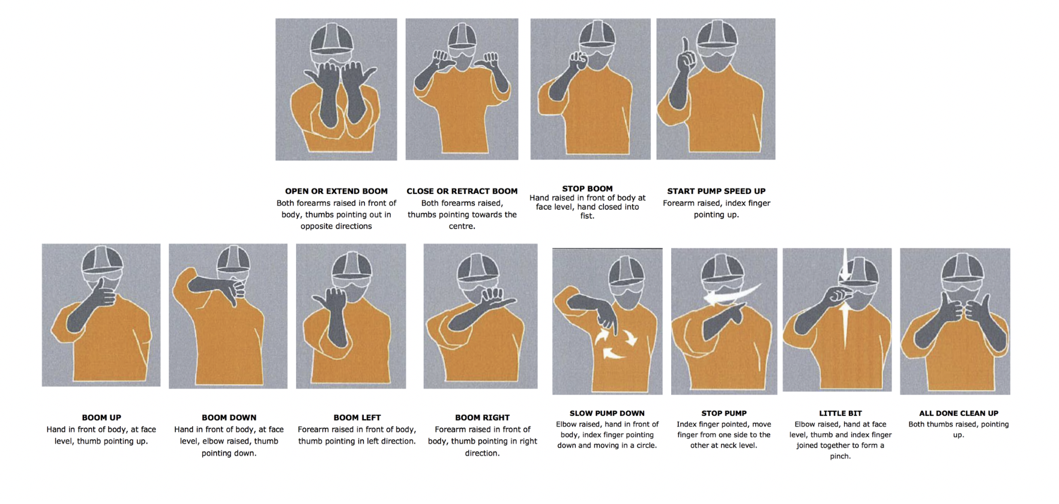
Additional task information

Add any additional hazards or risks that you identify for this task that are not listed above.

PPE required: |  | Signage required:
Work method statement

Describe how you plan to carry out the task by listing the step by step process e.g. 1. Arrive on site, 2. unload truck, 3. build scaffold etc. | Done
 | ☐
 | ☐
 | ☐
 | ☐
 | ☐
 | ☐
 | ☐
 | ☐
 | ☐
 | ☐
 | ☐
 | ☐
 | ☐

Safety briefing

You must conduct a safety briefing with all workers involved in this task. Explain the identified hazards and associated risks, the controls that will be put in place, and the proposed work method.

Name: |  | Signature:

Completed by: |  | Signed: |  | Date:

